**Topic 2: Open Source LLMs & Local Setup**

**Assignment 1:** Hugging Face Model Exploration

**Objective:**

The objective of this assignment is to explore an open-source Large Language Model (LLM) available on Hugging Face Hub and use it for a simple NLP task.

**Input:**

Environment setup commands (pip install transformers torch)

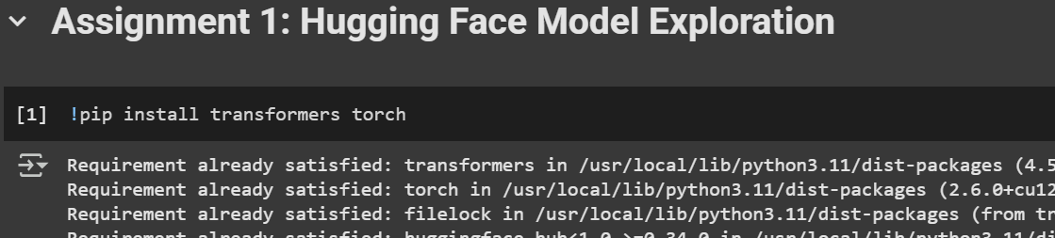

Code:

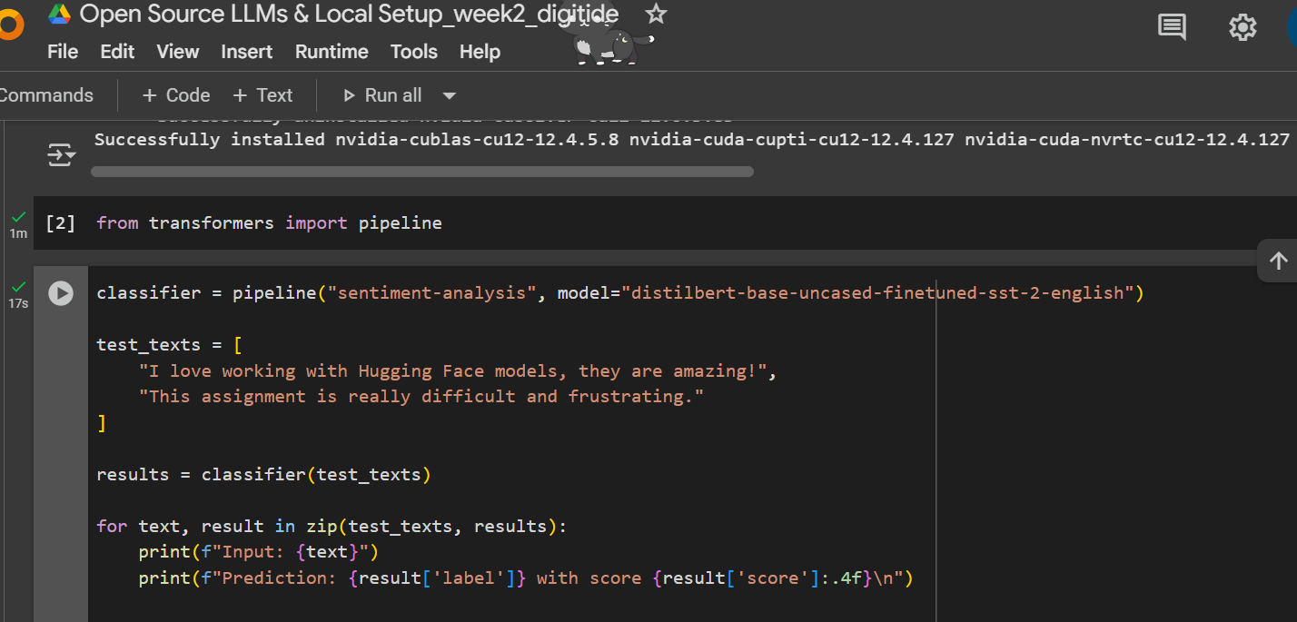

**Output:**

The model predicted the sentiment for each input sentence along with confidence scores.

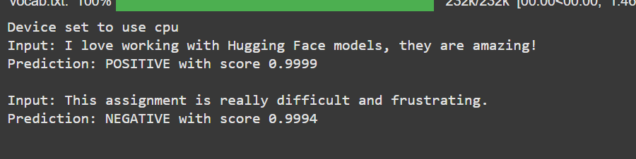

**Assignment 2:** Local LLM Installation and Testing

**Objective**

The objective of this task is to install a local Large Language Model (LLM) in Google Colab and test its functionality by running a simple prompt, measuring response time, and documenting any troubleshooting steps.

**Prompt and Output**



